1. **What exactly is []?**

**Ans***: [] represents an empty list. A list is a data structure that can hold a collection of elements, and when it's empty, it means there are no elements in the list.*

1. **In a list of values stored in a variable called spam, how would you assign the value 'hello' as the third value? (Assume [2, 4, 6, 8, 10] are in spam.)**

**Ans***: In Python, lists are indexed starting from 0. So, if you want to assign the value 'hello' as the third value in the list stored in a variable called `spam`, you would use index 2 to access the third position and then assign the value to it. Here's how you can do it:*

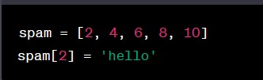

*After executing these two lines of code, the list `spam` will be `[2, 4, 'hello', 8, 10]`, with 'hello' as the third value in the list.*

*Let's pretend the spam includes the list ['a', 'b', 'c', 'd'] for the next three queries.*

1. **What is the value of spam[int(int('3' * 2) / 11)]?**

**Ans:** *Let's break down the expression step by step:*

*1. `int('3' * 2)` evaluates to `int('33')`, which is an integer conversion of the string '33', resulting in the integer `33`.*

*2. `int('33') / 11` evaluates to `33 / 11`, which is `3` in integer division.*

*Now, we have the expression `spam[3]`. Assuming that `spam` is the same list as mentioned in the previous answer `[2, 4, 'hello', 8, 10]`, this will access the fourth element of the list because list indexing starts at 0.*

*So, `spam[3]` will be `8`.*

1. **What is the value of spam[-1]?**
2. **Ans:** *In Python, negative indexing is used to access elements from the end of a list. `spam[-1]` would give you the last element of the list `spam`. Given the list `spam` as `[2, 4, 'hello', 8, 10]`, the value of `spam[-1]` is `10`, which is the last element in the list.*
3. **What is the value of spam[:2]?**

**Ans:** *In Python, when you use slicing with a list, you can specify a range of indices to create a new list containing elements from the original list within that range. The format for slicing is `start:stop`, where `start` is inclusive, and `stop` is exclusive.*

*In the case of `spam[:2]`, it means you want a new list containing elements from the beginning of `spam` up to (but not including) index 2.*

*Given the list `spam` as `[2, 4, 'hello', 8, 10]`, `spam[:2]` would result in a new list containing the elements at indices 0 and 1, which are `2` and `4`, respectively. So, `spam[:2]` is `[2, 4]`.*

1. **What is the value of bacon.index('cat')?**

**Ans:** It seems like there is a typographical error in your question. It should be `bacon.index('cat')` instead of `bacon.Index('cat')`.

The `index()` method is used to find the index (position) of a specified element in a list. If the element is not found in the list, it raises a `ValueError`.

Assuming that `bacon` is a list and you want to find the index of the string `'cat'` within that list, you would use the `index()` method like this:

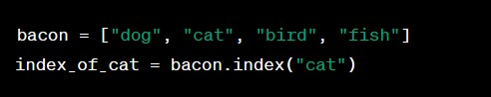

In this example, `index_of_cat` will be `1`, because "cat" is the second element in the list, and list indexing in Python starts at 0.

1. **How does bacon.append(99) change the look of the list value in bacon?**

**Ans:** *When you use the `append()` method in Python, it adds the specified element to the end of the list. So, if you execute `bacon.append(99)` on a list called `bacon`, it will add the integer `99` to the end of the list.*

*For example, if `bacon` was initially defined as:*

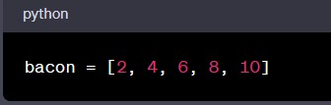

*After executing `bacon.append(99)`, the list `bacon` will be modified to:*

**

*As you can see, the `append()` method has added `99` to the end of the list, changing the look of the list.*

1. **How does bacon.remove('cat') change the look of the list in bacon?**

**Ans:** *If you use the `remove()` method on a list in Python to remove an element, it will remove the first occurrence of the specified value from the list. If the value is not found in the list, it will raise a `ValueError`.*

*However, in your provided code, you mentioned using `bacon.remove('cat')`, but you haven't shown the initial content of the list `bacon`. Therefore, the effect of this operation depends on whether 'cat' is present in the list or not.*

*If 'cat' is in the list, running `bacon.remove('cat')` will remove the first occurrence of 'cat' from the list. If 'cat' is not present in the list, the list will remain unchanged.*

*For example, if `bacon` is initially defined as*

**

*Running `bacon.remove('cat')` will change the list `bacon` to:*

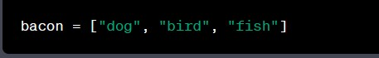

*In this case, the first occurrence of 'cat' is removed from the list. If 'cat' were not in the list, it would remain unchanged.*

1. **What are the list concatenation and list replication operators?**

**Ans:** *In Python, you can concatenate lists and replicate (duplicate) lists using the following operators:*

1. *\*\*List Concatenation Operator**: The `+` operator is used for list concatenation. It allows you to combine two or more lists into a single list. Here's an example:*

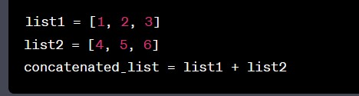

*After this operation, `concatenated_list` will be `[1, 2, 3, 4, 5, 6]`.*

*2. **List Replication Operator**: The `*` operator, when used with a list and an integer, replicates (duplicates) the list a specified number of times. Here's an example:*

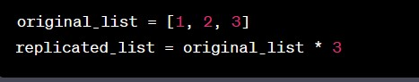

*After this operation, `replicated_list` will be `[1, 2, 3, 1, 2, 3, 1, 2, 3]`, which is the original list repeated three times.*

*These operators are useful for combining and replicating lists as needed in your Python programs.*

1. **What is the difference between the list methods append() and insert()?**

**Ans:** *The `append()` and `insert()` methods in Python are used to add elements to a list, but they differ in how and where they add elements:*

*1. append()` Method:*

*- The `append()` method is used to add an element to the end of a list.*

*- It takes a single argument, which is the element you want to add to the list.*

*- The added element becomes the last element in the list.*

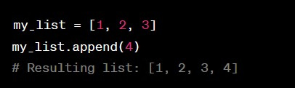

*2. insert()` Method:*

*- The `insert()` method is used to add an element at a specific position within the list.*

*- It takes two arguments: the index where you want to insert the element and the element itself.*

*- The added element is placed at the specified index, and existing elements may be shifted to make room for it.*

*Example:*

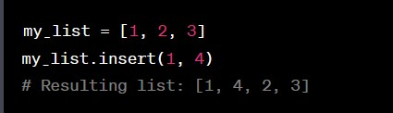

*So, the key difference is that `append()` adds elements to the end of the list, while `insert()` allows you to specify the position where you want to add an element.*

1. **What are the two methods for removing items from a list?**

**Ans:** *In Python, there are two common methods for removing items from a list:*

*1. remove()` Method:*

* *The `remove()` method is used to remove the first occurrence of a specific value from a list.*
* *It takes a single argument, which is the value you want to remove from the list.*
* *If the value is found in the list, it will be removed. If the value is not present, it will raise a `ValueError`.*
* *Example:*

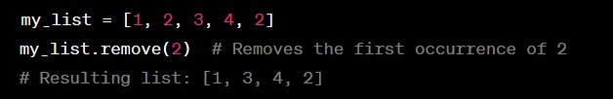

*2. pop()` Method:*

* *The `pop()` method is used to remove and return an element from a specific position (index) in the list.*
* *It takes an optional index as an argument. If an index is not provided, it removes and returns the last element in the list.*
* *If the index is out of range, it will raise an `IndexError`.*
* *Example: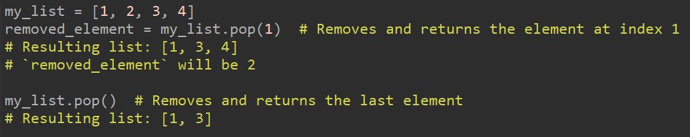*

*These two methods provide different ways to remove items from a list based on your specific needs. `remove()` is used to remove a value by its content, while `pop()` is used to remove an item by its index and can also return the removed item.*

1. **Describe how list values and string values are identical.**

**Ans:** *List values and string values are similar in some ways, but they also have important differences. Let's explore the similarities and differences between list values and string values:*

*1. Both Are Sequences: Both lists and strings are ordered sequences of elements. In a string, the elements are characters, while in a list, the elements can be of various data types, including other lists.*

*2.Indexing: You can access individual elements within both strings and lists using index notation. Indexing starts at 0 for both data types.*

*3. Slicing: You can use slicing to extract a portion of the data from both strings and lists. Slicing allows you to* ***create new strings or lists from parts of the original data.***

1. **What's the difference between tuples and lists?**

**Ans:** 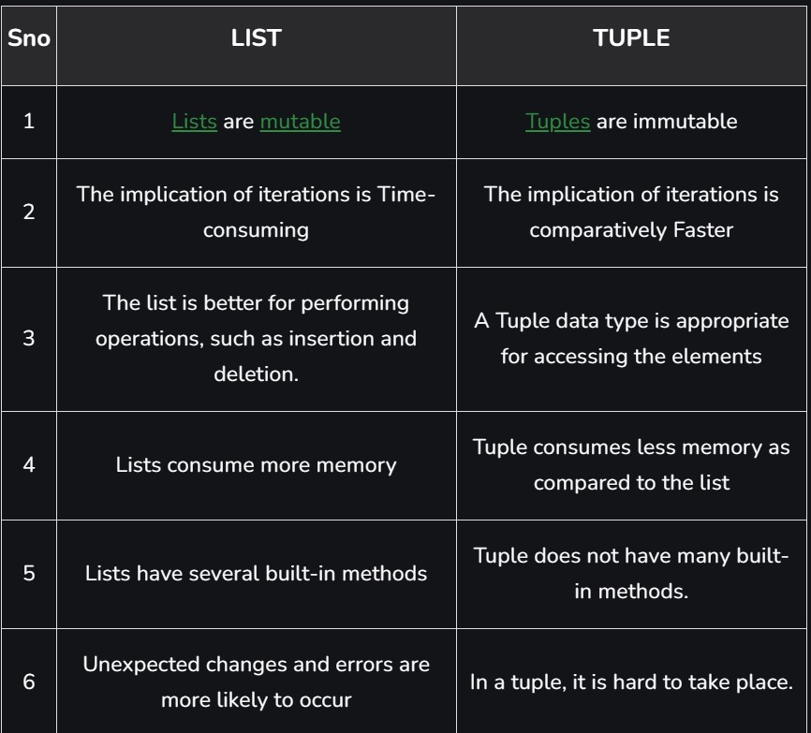

1. **How do you type a tuple value that only contains the integer 42?**

**Ans:** *To create a tuple containing only the integer 42, you can enclose the integer in parentheses. Here's how you can do it:*

**

*The trailing comma `,` is necessary to indicate that you are creating a tuple with one element. Without the comma, Python would interpret the expression as just an integer enclosed in parentheses, not as a tuple.*

1. **How do you get a list value's tuple form? How do you get a tuple value list form?**

**Ans:** *To convert a list to a tuple in Python, you can use the `tuple()` constructor, passing the list as an argument. For example:*

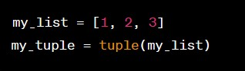

*After executing this code, `my_tuple` will be a tuple with the same elements as `my_list`.*

*Converting a tuple to a list can be done using the `list()` constructor. Here's how:*

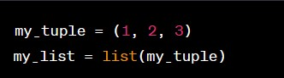

*Now, `my_list` will contain the elements of `my_tuple` in list form.*

*In both cases, you're using the constructor functions `tuple()` and `list()` to convert from one data type to another. This allows you to switch between lists and tuples as needed in your Python code.*

1. **Variables that "contain" list values are not necessarily lists themselves. Instead, what do they contain?**

**Ans:** *Variables that "contain" list values do not actually store the entire list directly; instead, they store references or pointers to the list. In Python, variables are essentially labels or names associated with objects in memory, and when you assign a list to a variable, you're actually storing a reference to the list in memory, not the list's data itself.*

*This distinction is important because it means that if you assign the same list to multiple variables, they will all reference the same list in memory. Here's an example to illustrate this: 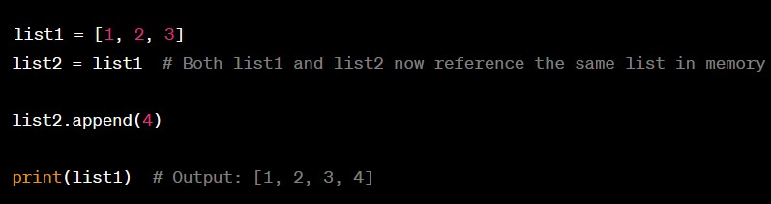*

*In this example, when we modify `list2`, `list1` is also affected because both variables reference the same list object in memory.*

*So, variables containing list values store references to those lists, allowing multiple variables to access and modify the same list, which is different from storing a copy of the list's data. This behavior is fundamental to how Python manages data and memory.*

1. **How do you distinguish between copy.copy() and copy.deepcopy()?**

**Ans:*****I****n Python, the `copy` module provides two functions, `copy.copy()` and `copy.deepcopy()`, that are used to create copies of objects, but they differ in how they handle nested objects within the original object:*

*1. `copy.copy()` (Shallow Copy):*

*- `copy.copy()` creates a new object that is a shallow copy of the original object.*

*- In the case of a list or other mutable objects, it creates a new object with a new top-level container (like a new list) and inserts references to the same elements (objects) as the original object.*

*- However, it does not create new copies of the elements themselves. This means that changes to nested elements within the copied object will affect the original object and vice versa if the elements are mutable.*

*Example:*

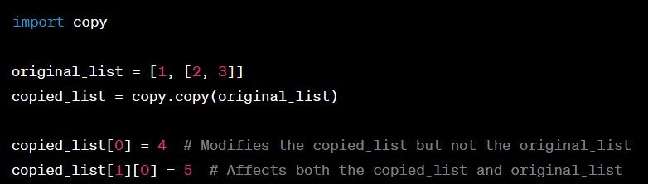

*2. `copy.deepcopy()` (Deep Copy):*

*- `copy. deep copy ()` creates a new object that is a deep copy of the original object.*

*- It recursively copies all the elements of the original object, including nested elements, and creates entirely new objects for every element. This means that changes to the copied object or its nested elements will not affect the original object.*

*Example: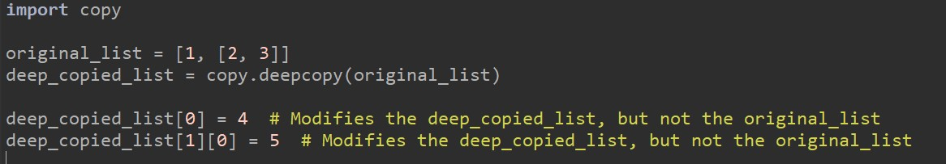In summary, the main difference is that `copy.copy()` creates a shallow copy that shares references to nested elements, while `copy.deepcopy()` creates a deep copy, creating entirely new objects for all nested elements, making it useful when you want to ensure that changes to the copied object do not affect the original object.*